 | 12.1.13 Editors - Geometry Nodes Editor - Header - Add Menu - Mesh
Table of content
Detailed table of content 1
Add menu - Mesh 2
Boolean 2
Edge Split 3
Mesh Subdivide 3
Subdivision Surface 4
Triangulate 5

Detailed table of content
Detailed table of content
Detailed table of content 1
Add menu - Mesh 2
Boolean 2
Inputs 2
Properties 2
Operation 2
Intersect 2
Union 3
Difference 3
Output 3
Geometry 3
Edge Split 3
Inputs 3
Geometry 3
Edge Angle 3
Angle 3
Sharp Edges 3
Outputs 3
Geometry 3
Mesh Subdivide 3
Inputs 4
Geometry 4
Level 4
Outputs 4
Geometry 4
Subdivision Surface 4
Inputs 4
Geometry 4
Level 4
Creases 4
Properties 4
UV Smooth 4
Boundary Smooth 4
Outputs 5
Geometry 5
Triangulate 5
Inputs 5
Geometry 5
Minimum Vertices 5
Properties 5
Quad Method 5
Beauty 5
Fixed 5
Fixed Alternate 5
Shortest Diagonal 5
Polygon Method 5
Beauty 5
Clip 5
Outputs 6
Geometry 6

Add menu - Mesh
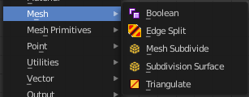
Nodes to modify the mesh geometry.

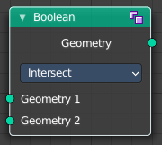
Boolean
The Boolean Node allows you to cut, subtract, and join the geometry of two inputs. This node offers the same operations as the Boolean modifier.

Inputs
Geometry 1, 2
Standard geometry input.

Properties

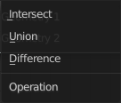
Operation
The boolean operation.

Intersect
Produce a new geometry containing only the volume inside of both geometry 1 and geometry 2.

Union
The two input pieces of geometry are joined, then any interior elements are removed.

Difference
Geometry 2 is subtracted from geometry 1 (everything outside of geometry 2 is kept).

Output

Geometry
Standard geometry output.

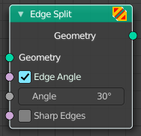
Edge Split
The Edge Split node splits as split edge marked edges into two edges.
Note that splitting edges breaks the mesh topology.

Inputs

Geometry
Standard geometry input.

Edge Angle
When enabled, edges will be split if the angle between its two adjacent faces is greater than the Split Angle.

Angle
On 0: all edges are split. On 180: no edges are split.

Sharp Edges
When enabled, edges will be split if they were marked as sharp.

Outputs

Geometry
Standard geometry output.

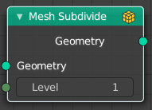
Mesh Subdivide
Subdivides the geometry by a simple division

Inputs

Geometry
Standard geometry input.

Level
To which degree the geometry will be deformed.

Outputs

Geometry
Standard geometry output.

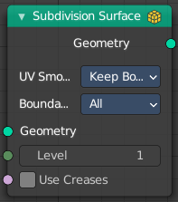
Subdivision Surface
The Subdivision Surface node subdivides the geometry using Catmull-Clark deformation.

Inputs

Geometry
Standard geometry input.

Level
To which degree the geometry will be deformed.

Creases
Control how smooth edges should be with Weighted Edge Creases.

Properties

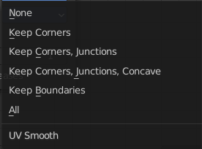
UV Smooth
The methbod to deal with smoothing the UV.

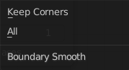
Boundary Smooth
Controls if open boundaries and corners are smooth.

Outputs

Geometry
Standard geometry output.

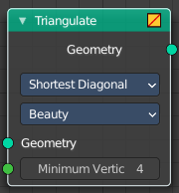
Triangulate
The Triangulate node triangulates all faces in a mesh.

Inputs

Geometry
Standard geometry input.

Minimum Vertices
Minimum number of vertices a face must have to be triangulated. For example, setting this value to 5, will prevent triangulation of Quads and only triangulate N-gons.

Properties

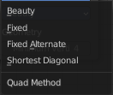
Quad Method
A quad is a polygon with four edges.

Beauty
Split the quads in nice triangles, slower method.

Fixed
Split the quads on their 1st and 3rd vertices.

Fixed Alternate
Split the quads on their 2nd and 4th vertices.

Shortest Diagonal
Split the quads based on the diagonal distance between their vertices.

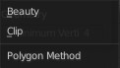
Polygon Method
Meant are N-Gons. Faces with more than four edges. Tris, Quads and N-Gons are all Polygons.

Beauty
Arrange the new triangles nicely, slower method.

Clip
Split the polygons using an ear-clipping algorithm (gives similar results to the tessellation used for the viewport rendering).

Outputs

Geometry
Standard geometry output.

